

ANNUAL REPORT

2013

Planning and Transport Research Centre (PATREC)

School of Earth and Environment M004
The University of Western Australia
35 Stirling Highway Crawley WA 6009
T +61 8 6488 3385
www.patrec.org

Director | Professor Sharon Biermann
Advisory Board Chair | Adjunct Professor Fred Affleck
Date | April 2014
Contents
1 INTRODUCTION 3
1.1 Initial establishment 3
1.2 Re-establishment 3
1.3 Advisory Board Members 3
1.4 Purpose 4
2 STRATEGIC DIRECTION 5
2.1 Direction setting 5
2.2 Value proposition 5
2.3 Framing research questions 6
2.4 Stakeholder uptake 7
3 PROGRAMS 8
4 RESOURCES 9
4.1 Core funding 9
4.2 People 9
4.3 Partnerships 10
5 PROJECTS 11
5.1 Completed 11
5.2 Proposed 11
6 EVENTS 12
7 PhD DEGREES AWARDED TO PATREC TOP-UP SCHOLARSHIP RECIPIENTS 13
8 PERFORMANCE CHECK AGAINST KPIs AND TARGETS 14

INTRODUCTION

Initial establishment
The Planning and Transport Research Centre (PATREC, Centre) was established in 2002 through a Memorandum of Understanding (MOU), with the participation of Western Australia’s four public universities and with involvement of the Government of Western Australia. The partner government agencies were not party to the MOU but participated through representation on the Advisory Board. The stated mission was to “undertake world class research and teaching in transport and associated fields for the benefit of Western Australia.” (MOU PATREC, 18 November 2002). PATREC was hosted by Curtin University until 2011 and a series of annual reports cover activities and outcomes until 2010.

Re-establishment
As a result of unfortunate financial irregularities in 2011, many planned activities in 2011 were either not achieved or fully accomplished and a process to recover funds and re-establish PATREC at the University of Western Australia (UWA), commenced. A new five year Collaborative Research Agreement, constituted “for the purposes of conducting collaborative research and teaching in the areas of transport policy and planning and urban and regional planning” was signed in April 2012 by the collaborating partners (UWA, Curtin University (Curtin), Edith Cowan University (ECU)), the Western Australian Planning Commission (WAPC), the Department of Transport (DoT) and Main Roads Western Australia (MRWA)). A new Director for the Centre was appointed in October 2012.

Two variations to the agreement were executed during 2013. The first was to include a clause ensuring that interest accrues on research funds. The second was to formalise the reduction in the contribution received from WAPC.

Advisory Board Members
The PATREC Advisory Board comprises a senior representative of each of the collaborating Parties and a Chair who is independent of all Parties. The PATREC Director is an ex officio member of the Advisory Board.

Table 1: PATREC Advisory Board membership
2011/2012 | 2013
Adjunct Prof Fred Affleck, Chair | Adjunct Prof Fred Affleck, Chair
Mr Charlie Thorn, Director Research and Development, Curtin University | Mr Charlie Thorn, Director Research and Development, Curtin University
Prof Geoff Syme, Professor of Planning, Edith Cowan University | Prof Geoff Syme, Professor of Planning, Edith Cowan University
Mr Tim Shanahan PSM, Director, Energy and Minerals Institute, The University of Western Australia | Mr Tim Shanahan PSM, Director, Energy and Minerals Institute, The University of Western Australia
Ms Sue McCarrey, Deputy Director General, Department of Transport | Ms Sue McCarrey, Deputy Director General, Department of Transport
Mr Menno Henneveld, Managing Director, Main Roads Western Australia | Mr Stephen Troughton, Managing Director, Main Roads Western Australia
Mr Gary Prattley, Chair, Western Australian Planning | Mr Eric Lumsden, Chair, Western Australian Planning Commission
 | Prof Sharon Biermann, Director PATREC

Purpose
It was agreed by the Advisory Board on 13 June 2013 that due to the hiatus in research activities during 2011 and 2012 during the re-establishment process, it would not be necessary or useful to retrospectively prepare individual annual reports for those years but that an annual report for 2013 would be prepared, referring to the re-establishment process and incorporating any achievement made during that period.

The primary purpose of this report is to provide an update of activities conducted and outcomes achieved as part of PATREC during 2013 following the re-establishment activities of 2011 and 2012. The report also makes reference to achievements made during the 2011/12 period despite the transition to a new dispensation, largely in the area of PhD’s awarded to recipients of PATREC top-up scholarships.

STRATEGIC DIRECTION

Direction setting
The PATREC Strategic Business Plan 2013-2016 (Plan) was approved by the Advisory Board on 13 June 2013. The Plan was compiled through a process of engagement with a range of PATREC stakeholders in the planning and transport arena, including leading academics, industry representatives and influential policy partners from state and local government. More than 60 one-on-one discussion and two stakeholder workshops were held during the period November 2012 to February 2013 with the purpose of exploring the most beneficial role and research focus for PATREC in advancing the integrated planning and transport knowledge base and providing enhanced evidence to inform policy decisions.

The Plan sets out the broad strategic direction of PATREC for the four year period 2013-2016 and provides a more detailed action focus for the inner year, 2013. The Plan is structured in three parts. Following the introductory section which provides the background to PATREC’s current position and the purpose and process of developing the Plan, the second part presents the Strategic Direction with a four year focus which sets out what PATREC will be doing, the context within which it is operating, resourcing allocations for delivery and Key Performance Indicators for measuring the success of delivery. The third part comprises the Business Plan which provides a more detailed view of goals, actions, deliverables, resourcing and a budget for the inner year of 2013.

Value proposition
The aim of PATREC is to deliver research that extends the evidence-base in support of the effective planning and management of Western Australia’s future in transport and land use.

Capitalising on its extended network of academic expertise and policy partners, PATREC brokers and conducts:
- Policy-informing, multi-disciplinary, multi-institutional research;
- Knowledge transfer – publications, connection events,;
- Training - professional development short courses on key topics; and
- Leveraging of additional research funding.

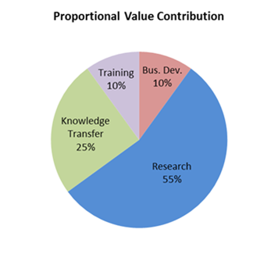
For 2013, these activities respectively comprised 55, 25, 10 and 10 percent of the total PATREC portfolio of work (Figure 1).
Figure 1: Proportional representation of areas of value

Framing research questions
To enable the expedient focus, organisation, management and delivery of a PATREC research program, and to ensure a strong multi-disciplinary approach, the identified research focus areas have been encapsulated within the ambit of two “big” research questions each with a number of sub-questions:

- Research Question 1: What are the multi-perspective impacts of and solution for decoupling economic growth and liveability in metropolitan Perth – accommodating economic growth whilst retaining and enhancing quality of life?
  - What are the sustainable models of urban form to accommodate growth and frame infrastructure investment – local and metropolitan scales?
  - How well do these models perform against a set of multi-disciplinary evaluation indicators?
  - What is the best integrated modelling platform for evaluating impacts?
  - How can demand be better managed to reduce the need for more infrastructure – intelligent transport, pricing mechanisms and socio-behavioural factors?
  - How can increasing urban freight levels best be accommodated in a dense urban context – economics of congestion and land use conflicts?
  - What are the implemented barriers – governance, funding, institutional and cultural?
- Research Question 2: What are the dynamics and mechanisms involved in building the competitive and collaborative advantages of the regions of WA?
  - What are the most efficient modes of freight transport to overcome the tyranny of distance?
  - What is the role of transport in the different regional contexts and in the growing and lagging regions?
  - What are the demographic changes happening to explain why some towns are declining and others growing?
  - What are the impacts of rate of change in indigenous areas on transport and how is community resilience impacted by a changing transport context?
  - What governance arrangements could improve the inconsistency and lack of uniformity in the networks and responses across the state?
  - What is the effectiveness of SuperTowns and Royalties for Regions in achieving objectives?

Stakeholder uptake
Following a workshop of the Transport Portfolio held on 6 June 2013, a list of research topics and priority questions was developed in response to the Strategic Business Plan:
- Modelling/Data
- Integrated LU-T planning – TOD implementation
- Infrastructure Funding
- Intelligent Transport Systems
- Demand Management

The RAC, Advocacy and Member Benefits, has provided funding to PATREC for undertaking “a finite program of research relating to traffic and transport planning with the aim of working collaboratively with stakeholders to address key transport industry data needs to support decision making and long term planning”. The value of the program is capped at $200K and each project can only proceed and program funds may only be expended or drawn upon once a scope of works, methodology, final fee and contract has been mutually agreed by both PATREC and the RAC. PATREC is required to provide a detailed proposal in response to project briefs provided by the RAC for each project. The proposed research topics areas are (not exclusively):
- Developer Contribution models
- Integrated land use and transport modelling base data
- Car parking modelling
- Trip generation rates
- Benchmarking and performance monitoring.

PROGRAMS
In response to the research needs and questions arising from the stakeholder-informed strategic planning process, the research competence base across the three collaborating universities and emerging external funding opportunities, four PATREC research programs were formed as a pragmatic means to undertake research and deliver high-impact outcomes, although collaboration across programs is expected and required. The emphasis is on urban research with a program each on integrated land use-transport planning and policy (integration), modelling, economics and information (information) and infrastructure funding and implementation (implementation) (Figure 2). One of the programs is focussed on regional planning and transport and is cross-cutting in relation to integration, information and implementation. Aspects of freight, travel demand management and spatial analysis will be incorporated to a degree in all programs.

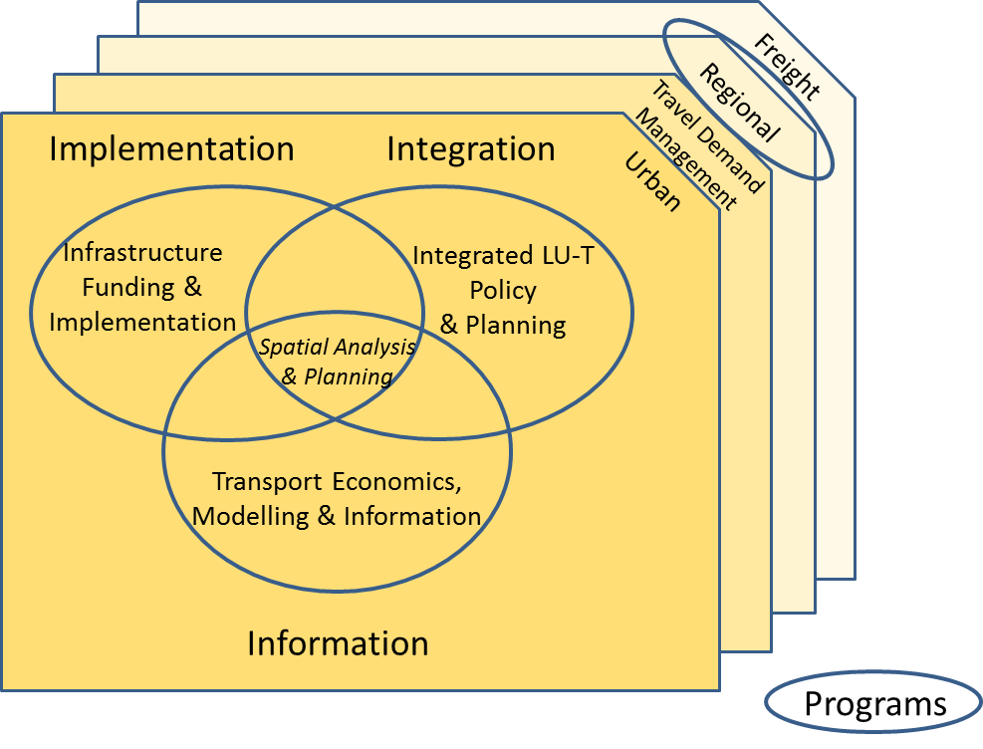
Figure 2: PATREC core research programs and cross-cutting areas

RESOURCES

Core funding
The 2012 PATREC Collaborative Research Agreement committed the collaborating partners to a total of $420,000 per year for 2012, 2013 and 2014 and makes provision for the same or an amended schedule of cash contributions for 2015 and 2016. During the course of 2013, the WAPC reduced their contribution by $50,000 due to financial constraints. This core sponsorship amount essentially covers the salaries and operating costs of the PATREC office and some connection event costs. It is the “balance carried forward” funds, accumulated from before and during the re-establishment phase, including recovered funds, when little expenditure on research occurred, that allows for some research leverage. In order for PATREC to remain financially sustainable over the longer term, and to provide sufficient impetus for making an impact, PATREC will need to charge a “brokering” fee, levied as a percentage of the total cost of an external contract or grant obtained where PATREC has added value. In addition to brokering fees, the opportunity to sign up additional sponsors and charging fees for short courses exists to increase income levels.

People
A core research team of researchers from the partner universities has been assembled on the basis of a formal request for expressions of interest followed by an interview process (Table 2). Full time equivalents and time period of involvement were negotiated with each individual team member. In addition, Dr Valerià Paül has been appointed as the PATREC Research Development Officer with part of his role being that of Research Associate for the Regional Planning and Transport Program.
Table 2: PATREC core research team and PhD top-up scholarships awarded
PATREC CORE RESEARCH PROGRAM | RESEARCH PROGRAM LEADER | RESEARCH ASSOCIATE | PhD TOP-UP SCHOLARSHIP
Integrated LU-T Policy and Planning | Professor Carey Curtis  (Curtin-Built Environment)  0.6 FTE, 1 yr | Courtney Babb  (Curtin-Built Environment)  0.5 FTE, 2 yrs | Daniel McDonald  (ECU - Planning)  20k/yr for 2 yrs
Infrastructure Funding and Implementation | No appointment made. | James McIntosh initially appointed but withdrawn and converted to a partial PhD top-up scholarship to ensure PhD delivery. | Sai Kumar  (Curtin – CUSP)  20k/yr for 3 yrs  James McIntosh  (Curtin – CUSP)  10k for 1 yr – PhD completion
Transport Economics, Modelling and Information | Assoc. Professor Doina Olaru  (UWA Business School)  0.25 FTE, 2 yrs | Assis. Professor Brett Smith  (UWA Business School)  0.5 FTE, 2 yrs
Regional Planning and Transport | Dr Amanda Davies  (Curtin-Built Environment)  0.6 FTE, 1yr | Assis. Professor Valerià Paül (UWA PATREC)  0.4 FTE, 3 yrs

Partnerships
A number of potential partners beyond the core research team have been identified and engaged with to explore collaboration opportunities. These include other research groups within the partner universities, planning and transport consultants and professional groups and previous research associates of PATREC (Figure 3). Beyond WA, a working relationship has been established with Griffith University’s Urban Research Group and the University of Sydney’s Institute of Transport and Logistic Studies (ITLS). Collaborations already existed between these groups and core research team members in addition to a range of others, but these two groups stand out as key collaborations to pursue as a matter of priority.
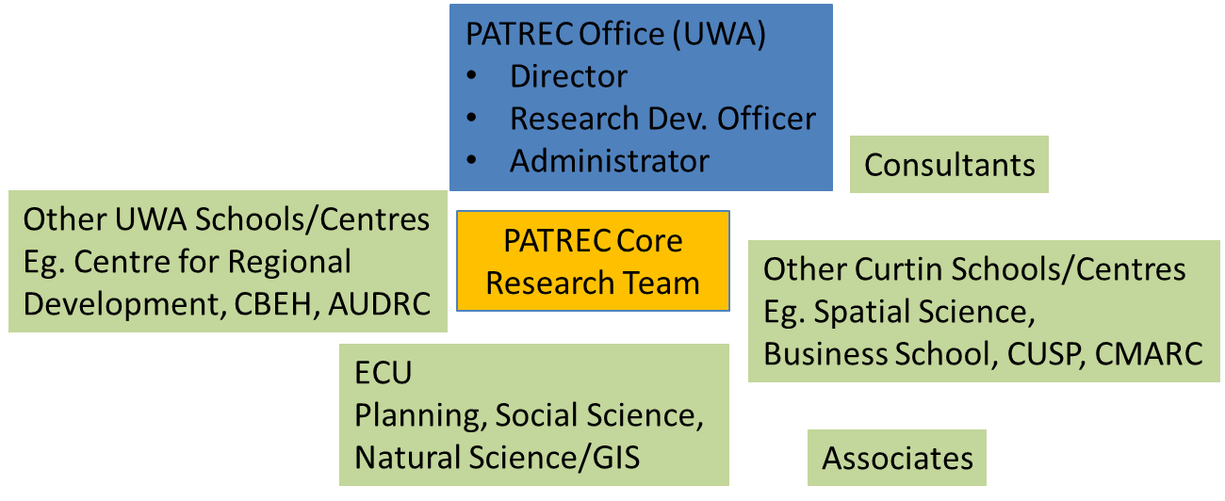
Figure 3: Potential collaborators within PATREC partner universities

PROJECTS

Completed
- Cycling Business Case – external contract undertaken by PATREC associate Ian Kerr for the RAC. Initiated during the PATREC re-establishment period. Resulted in glossy information brochure published by the RAC. Presented at the IAG conference in July 2013 ($45k).
- Literature Review: Developer Contributions – external contract undertaken by Curtin University Sustainability Policy (CUSP) Institute for the RAC. Resulted in a client report (Proposed - $43k, stage 1 done - $14k).

Proposed
- WA Data Hub proposal submitted to The Australian Urban Research Infrastructure Network (AURIN) has been accepted ($198k).
- Independent Transport Modelling Review proposal submitted and accepted and project commenced for Transport Portfolio ($128k).

EVENTS
PATREC hosted a variety of connection events for stakeholders during 2013 for the purpose of knowledge transfer, communication and networking.

Table 3: PATREC-hosted connection events in 2013
Event | Date | Attendees
First workshop setting PATREC’s strategic research direction:  Rapid growth development futures:  An integrated planning and transport research response | 10 December 2012 | 40
Second workshop setting PATREC’s strategic research direction:  Rapid growth development futures:  An integrated planning and transport research response | 22 February 2013 | 25
Table hosted by PATREC: Presentation of Bernard Salt: ‘How to Deliver the Western Ascendancy’ | 10 May 2013 | 10
ARC Linkage workshop (collaborating universities only) | 11 June 2013 | 16
PATREC session (with 9 presenters) at IAG Conference 2013  - Lauren Aitken (DoT): MAX light rail planning framework  - Prof Sharon Biermann (UWA-PATREC): Containing the uncontainable – reducing the need to travel by the spatial balancing of jobs and workers  - Adj/Prof Fred Affleck (PATREC): Integrated freight and land use planning  - Dr John Smoker (New Perspective Ventures): The Terra Nullius of Infrastructure: Roads to Remote Indigenous Towns  - Dr Anthony Duckworth-Smith (AUDRC): Mean Streets: residential intensification strategies for roadway corridors  - Assoc/Prof Doina Olaru (UWA): What do Perth travellers think about Park-and-Ride (PnR) and how do they choose the PnR station?  - Ian Ker (CATALYST): Black Holes to Economic Cycles: Rediscovering Cycling as an Economic Activity  - Dr Paula Hooper (UWA): Evaluating the Implementation of a state government planning policy designed to create walkable neighbourhoods in Perth and associations with walking behaviour  - Dr Sarah Foster (UWA): Do the characteristics of a walkable neighbourhood impact residents’ perceptions of crime risk? | 1-4 July 2013 | ~150
Inaugural Seminar on Tackling Congestion: Exploring Practical Approaches for Managing Travel Demand in Perth  - Assistant Prof Brett Smith (UWA): Defining Transport Demand Management  - Professor Carey Curtis (Curtin): Land use mechanisms  - Mr Edmund Salt ARRB Group Ltd): Pricing measures  - Professor Geoff Syme (ECU): Social-psychological/ behavioural factors | 20 August 2013 | 30
Second seminar on Tackling Congestion: The Role of Cost in Influencing Travel Behaviour in Perth  - Associate Prof Doina Olaru (UWA): Park and Ride Perceptions and Choices of Perth’s Travellers  - Mr Larry Schneider (Luxmoore Parking and Safety/ARRB; President, Parking Association of Australia): Parking Strategies  - Dr Catherine Ferguson (ECU): Cost as a Motivator for People’s Behaviour | 12 November 2013 | 40
Seminar by visiting Professor Mark Oranje: “Spatial Development Planning in Post-1994 South Africa: Influences, Approaches and Outcomes” | 11 December 2013 | 12

PhD DEGREES AWARDED TO PATREC TOP-UP SCHOLARSHIPS RECIPIENTS
The PhD candidates listed in Table 4 were awarded PATREC top-up scholarships before the PATREC re-establishment stage. All three have submitted their PhD theses and all but one already graduated.

Table 4: Progress of PhD candidates with PATREC top-up scholarships awarded pre-2011
PhD candidate | Ms Izumi Hart
Title of thesis | Preliminary investigation into the measurement of safety culture in the Australian rail industry
Supervisor(s) | Emeritus Professor Laurence Hartley
Date of completion | Graduation planned mid 2014
Number of Publications | Several confidential technical reports for the participating organisations in the course of the research project (not publicly available)
Associated University | Murdoch University
PhD candidate | Mr John Smoker
Title of thesis | The Terra Nullius of Infrastructure: Roads to Remote Indigenous Towns
Supervisor(s) | Prof Peter Newman
Date of completion | December 2012
Number of Publications | Conference paper presented at IAG conference in July 2013
Associated University | Curtin University
PhD candidate | La Ngoc Quang
Title of thesis | Road crash and injury of bus and taxi drivers in Hanoi, Vietnam
Supervisor(s) | Prof Andy Lee
Date of completion | November 2011
Number of Publications | 2 (DOI:10.1080/17457300.2012.748810 & 10.1016/j.aap.2012.05.022)
Associated University | Curtin University

PERFORMANCE CHECK AGAINST KPIs AND TARGETS
Broad key performance indicators set for PATREC relate directly to the value-add role or purpose that PATREC was established for. The university collaborators require an increase in research profile and performance while the government partners require better evidence on which to base policy and investment and development spending decisions. The following list of performance indicator categories for PATREC was compiled from the partner universities’ policies on the establishment and review of research centres, supplemented with knowledge transfer indicators of policy impact:
- Performance impacts for enhanced research capacity;
- Profile impacts for improved competitive advantage;
- Productive partnerships for institutional vitality; and
- Policy-relevant evidence for knowledge transfer.

Indicators and targets set for 2013 in the Business Plan for 2013 are primarily “input” indicators for this re-establishment year (Tables 5 and 6). Performance was largely on track with the exception of delayed appointment of the core team. Although offers were made in August 2013, release from current duty as normal was only possible from 2014. This delay resulted in delays in the producing of program plans/frameworks. Due to the timeframe for submission of ARC Linkage grant proposal, the target of two submissions in 2013 was not possible. Although two client reports were produced, targets were not met in terms of converting these into PATREC working papers or factsheets.

Table 5: Performance in relation to key performance indicators
Key outputs envisaged in 2013 | Achieved in 2013
Two research program frameworks for the two big research questions | Four research programs established.
At least four detailed project plans prepared and submitted for funding applications with a “basic” plan for continuing work on the project with no additional funding and a “comprehensive plan” indicating the work to be undertaken if additional funding applications are successful  Target value of proposals: $400k | Three detailed project plans prepared (see section 5: Developer Contribution ($43k), WA Data Hub ($198k) and Modelling Review ($128k)  Total value proposed: $369k
Baseline analyses for the two program areas (first deliverable of approved projects)  - Presented at two special topic seminars to showcase the multi-disciplinary research  - Published in two Working Papers  - Published in two Fact Sheets | - Two working client reports on baseline analysis (see section 5)  - Infrastructure Financing Program – Literature Review of Developer Contribution  - Independent Transport Modelling Review – Best practice review  - Two special topic multi-disciplinary seminars relating to Tackling Congestion (see Table 3)
Two connection events - one with visiting speakers (local and possibly national) – one to do with planning and transport information – AURIN and BITRE, Land gate | Two connection events (Table 3):  - Visiting Professor: Spatial Planning seminar  - Bernard Salt table
Research Advisory Committees established and operational for each of the program areas | Project level Steering/Working Committees for:  - AURIN project  - Independent Modelling Review
Revitalised website | - Look-and-feel of the PATREC website changed to reflect the re-establishment  - All relevant documents, such as annual reports, papers and publications recovered from the former website, now published on the current website  - Strategic Business Plan published. Mission and vision statement revised.  - ”News and Calendar” added.
Two ARC Linkage Project proposals submitted | - Co-ordination workshop held to plan for Oct 2014 submissions (Table 3)
Four journal articles submitted | - Book chapter submitted (Director)  - Physical verification of household rainwater tank systems to investigate if installation follows design specifications and regulation. Co-authored with Reid Butler in Rainwater Tank Systems for Urban Water Supply: Design, Yield, Health Risks, Economics and Social Perceptions (eds) Ashok Sharma, Don Begbie and Ted Gardner, IWA Publishing  - Peer reviewed conference paper published in proceedings (Director) – SOAC, Sydney, Nov 2013  - Sufficiency of self-sufficiency employment targets in reducing the need to travel. Co-authored with Assistant Prof Kirsten Martinus, UWA  - Three journal articles submitted by James McIntosh et al (PhD top-up scholarship to compete PhD and associated publications)  - McIntosh J., Trubka R., Newman P. (2013) Can Value Capture work in a car dependent city? Willingness to pay for transit access in Perth, Western Australia Transport Research - Part A.  - McIntosh J., Trubka R., Newman P. (2013) Tax Increment Financing framework for integrated transit and urban renewal projects in car dependent cities. Australian Economic Review  - McIntosh J., Kenworthy, J., Trubka R., Newman P. (2013) Framework for Land Value Capture from the investment in transit in car dependent cities. Journal of Transport and Land Use
Four conference papers presented | - Nine conference papers presented at IAG special PATREC session in July 2013 (Table 3)  - SOAC conference paper presented, Sydney, Nov 2013 (Director): Sufficiency of self-sufficiency employment targets in reducing the need to travel.
Audit of training courses and industry needs to identify gaps and collaboration opportunities | Not done.

Table 6: Summary statistics of performance in relation to set targets
Key Performance Indicators 2013 | Targets 2013 | Achieved  2013 | Qualification
Performance impacts for enhanced research capacity
Number of funding applications submitted | 2 | 3 | Section 5
Number of journal articles submitted | 4(2*) | 5(2*) | Including book chapter, peer reviewed conference paper publication
Number of PhD graduates planned in projects | 4 | 0
Profile impacts for improved competitive advantage
Research Development Officer from 1 July 2013  Postdocs appointed from 1 July 2013  Number of PhD top-up sponsorships awarded | 1 (1*)  2  4 | 1 (1*)  2  3 | PATREC RDO – offer accepted in 2013, appointment in Feb 2014  2X postdocs - offers in Aug 2013  3X research leaders – offers in Aug 2013  Top-ups – 3X awarded
Value of additional research funding proposed | $400k |  | $366k
Productive partnerships for institutional vitality
Attendance number at stakeholder workshop and 4 connection events | 150 | 323 | Table 3
Number of international collaboration agreements negotiated | 4 (2*) | 0 | Incorrectly targeted. Should have been a target of zero for 2013
Number of joint projects approved  Number of joint HDR student supervision  No. of joint authored journal articles submitted | 4  4  4 | 3  0  5
Policy-relevant evidence for knowledge transfer
Number of project plans with policy links proposed  Number of RACs established and functional | 4  2 | 3  3
Number of Working Papers published | 2 | 2 | Client reports
Number of factsheets published | 2 | 0
Number of conference papers presented | 4(2*) | 10(2*)
Number of connection events | 4 | 4 | 2X special topic; 2X connection
Number of short courses planned in projects | 4 | 0
*Director’s own direct KPIs included in parenthesis

